Incident Information
Location of the incident: _________________________________________________________
(Photocopy and include a map of your trip location, so you can draw on it)
Mechanism of injury (fall, rock fall, avalanche, etc. ___________________________________
Time of incident ______________________ Number of Subjects ___________________

Subject Information

Subject 1: Name, Appx Aage___________________________________________________
Suspected injuries: ________________________________________________________________________________________________________________________________________________________
Level of consciousness ( Conscious / Unconscious ) At Time _________________
Pulse _______________ Respiration ___________________ Description _____________

Medications and/or medical conditions:_______________________________________________________________________________________________________________________________________________

Does this subject require rapid transport to advanced medical care ( YES / NO )

Subject Information

Subject 2: Name, Appx Aage___________________________________________________
Suspected injuries: ________________________________________________________________________________________________________________________________________________________
Level of consciousness ( Conscious / Unconscious ) At Time _________________
Pulse _______________ Respiration ___________________ Description _____________

Medications and/or medical conditions:_______________________________________________________________________________________________________________________________________________

Does this subject require rapid transport to advanced medical care ( YES / NO )

Subject Information

Subject 3: Name, Appx Aage___________________________________________________
Suspected injuries: ________________________________________________________________________________________________________________________________________________________
Level of consciousness ( Conscious / Unconscious ) At Time _________________
Pulse _______________ Respiration ___________________ Description _____________

Medications and/or medical conditions:_______________________________________________________________________________________________________________________________________________

Does this subject require rapid transport to advanced medical care ( YES / NO )

Subject Information
Subject 4: Name, Appx Aage___________________________________________________
Suspected injuries: ________________________________________________________________________________________________________________________________________________________
Level of consciousness ( Conscious / Unconscious ) At Time _________________
Pulse _______________ Respiration ___________________ Description _____________

Medications and/or medical conditions:_______________________________________________________________________________________________________________________________________________

Does this subject require rapid transport to advanced medical care ( YES / NO )

Additional Subject Information
____________________________________________________________________________________________________________________________________________________________________________________________________________________________________

Rescuer Information
Number of rescuers: ______
Name of rescuer(s):
Rescuer 1: _________________________ | Rescuer 4: _________________________
Rescuer 2: _________________________ | Rescuer 5: _________________________
Rescuer 3: _________________________ | Rescuer 6: _________________________

Rescue plan: ________________________________________________________________________________________________________________________________________________________________________________________________________________________________________________________________________________________________________________

Rescuers departure time: __________ Rescuers expected back at camp time: _____________

Rescuers radio channel: ___________

Rescue equipment taken: ________________________________________________________________________________________________________________________________________________________________________________________________________________________________________________________________________________________________________________

Does the rescue require:
____ | Helicopter evacuation | ____ | Oxygen pack
____ | Technical rope rescue | ____ | Overnight pack (how many people)
____ | Avalanche search and rescue | ____ | Additional personnel
____ | Trauma pack | ____ | Food and water

Other rescue requirements: ________________________________________________________________________________________________________________________________________________________________________________________________________________________________________________________________________________________________________________

Are there any safety concerns for the rest of the party of subsequent rescuers?
________________________________________________________________________________________________________________________________________________________________________________________________________________________________________________________________________________________________________________________________________________________________________________________________________________________________________________________________________
Medical Incident Report Form
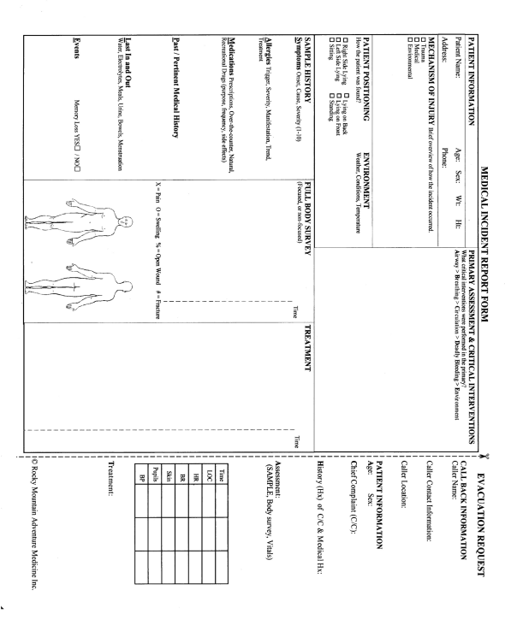

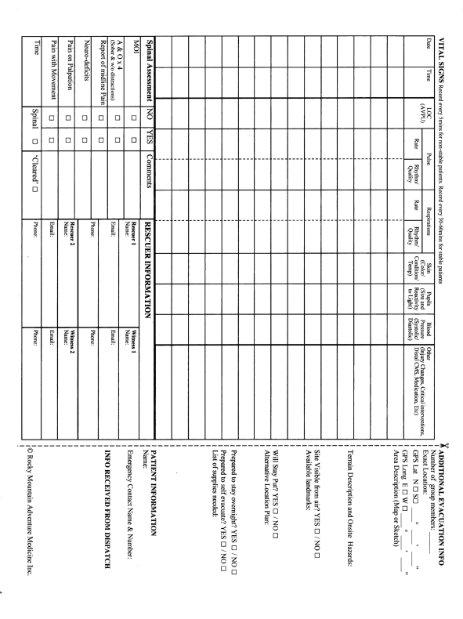

Lake Louise Self-Assessment Scorecard
Acute Mountain Sickness - Altitude Sickness

The Lake Louise Self Assessment Scorecard was established as a method of quantifying altitude sickness. Due to its compact format it has been used by mountaineers for the assessment of AMS.
Each category is scored individually.

Headache
0 No headache
1 Mild headache
2 Moderate headache
3 Severe headache, incapacitating

Gastrointestinal Symptoms
0 No symptoms
1 Poor appetite or nausea
2 Moderate nausea or vomiting
3 Sever nausea and vomiting, incapacitating

Fatigue and weakness
0 Not tired or weak
1 Mild fatigue/weakness
2 Moderate fatigue/weakness
3 Severe fatigue/weakness, incapacitating

Dizziness and light-headedness
0 Not dizzy
1 Mild dizziness
2 Moderate dizziness
3 Severe dizziness, incapacitating

Difficulty sleeping
0 Slept as well as usual
1 Did not sleep as well as usual
2 Woke many times, poor night’s sleep
3 Could not sleep at all

Total Score: ___________________

A total score of 3 or more plus a headache constitutes AMS.
Repeated scoring is used to monitor progression of AMS.

